CS4121 Assignment 4 Due: 10/23/19

- (15 points) ) Suppose a TCP segment of size 3000 bytes (including data plus application overhead plus TCP headers) is passed to IP for delivery across three networks of the Internet (i.e. from the source host to a router say R1 to another router say R2 then to the destination host).

The first network has an MTU of 1260 bytes; the second network has an MTU of 880 bytes; and the third network has an MTU of 1100 bytes. Each network’s MTU gives the size of the largest IP datagram that can be carried in a data-link layer frame. Assume all IP headers are 20 bytes. Give value of the flag, the length (header + data) and offset fields of the sequence of fragments delivered to the network layer at R1, R2, and the destination host. It is important for you to be reminded that segment reassembly is only done at the final destination host.
You must justify your answers. No justification=0 point.
MTU=1260 bytes

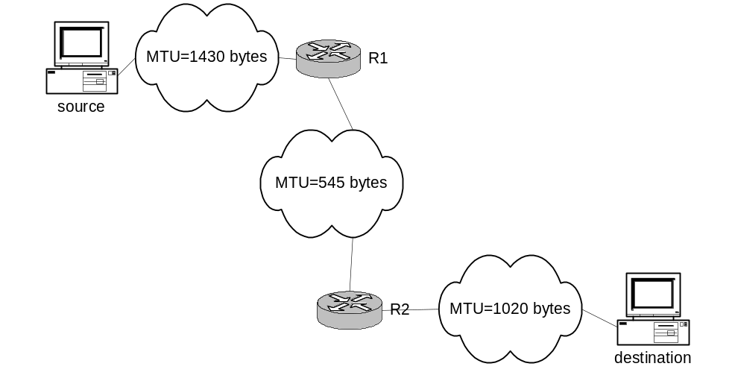
MTU=880 bytes
MTU=1100 bytes

For each of R1, R2, and the destination host, I am expecting a table like following.

R1:
Flag | Offset | Length
1 | 0 | 1260
1 | 155 | 1260
0 | 310 | 540
1240 is a multiple of 8 so offset is 155.

R2:
Flag | Offset | Length
1 | 0 | 876
1 | 107 | 404
1 | 214 | 876
1 | 321 | 404
0 | 428 | 540
Split previous segments because MTU 880 < 1260.
860 is not a multiple of 8. So, we use the closest one being 856. The offset is 107.

Destination Host:
Flag | Offset | Length
1 | 0 | 876
1 | 135 | 404
1 | 270 | 876
1 | 405 | 404
0 | 540 | 540
Since MTU 1100 > 880 it is not split.
1080 is a multiple of 8 so offset is 135.

